

LAB REPORT 2

CFS3133 K4

WEB-BASED INTERFACE DESIGN

NAME: AIN SUFIAH BINTI AZMAN

NO. MATRIK: S76105

DATE: 29/10/2025

LAB DEMO: MRS. WAN FATIN FATIHAH

**2.3WORKING WITH TABLES**

1. 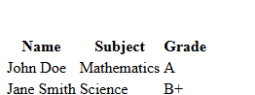

2. 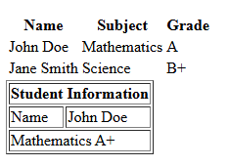

**2.4 CREATING FORMS**

2.4.1 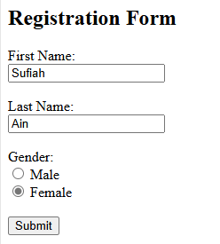

2.4.2 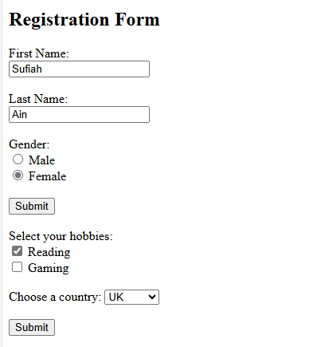

**2.5 SEMANTIC HTML**

2.5.1 Common Semantic Tags

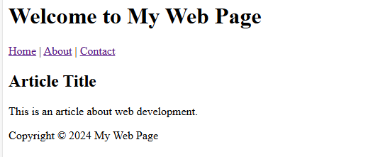

**2.6 LAB EXERCISE 2**

2.6.1 Building a Personal Profile Page

